**Ganadipathy Tulsi's Jain Engineering College**

Kaniyambadi - Vellore - 632102

**NAAN MUDHALVAN - PROJECT**

**CREATING A SOCIAL MEDIA AD CAMPAIGN**

**IN FACEBOOK**

### 

### *Submitted By,*

Team Leader - Vickram D

Team Member 1 - Hariharan S

Team Member 2 - Ranjitha K

Team Member 3 - Vasanth P

# Project Mentor Project Evaluator Project Spoc

## Mrs.Priya Mrs.Priya Mr.Durai Kumar

**INDEX**

**1. INTRODUTION**

1.1 NAVIGATION

**2. SEARCH “FACEBOOK”**

**3. META BUSINESS SUITE**

**4. ADS**

**5. CREATE AD**

5.1 CLICK “CREATE AD” ON TOP RIGHT CORNER

**6. CHOOSE GOAL**

6.1 MORE LEADS

**7. COLLECT CONTACT IN FACEBOOK**

**8. NEW FORM**

8.1 ADD DETAILS

8.2 CLICK NEXT

**9. ADD DESCRIPTION**

**10. ADD MEDIA**

10.1 CLICK “SELECT MEDIA”

10.2 CLICK UPLOAD AND UPLOAD IMAGES FOR YOUR AD

**11. HEADLINE**

11.1 ESTIMATED RESULTS

**12. CREATE AUDIENCE**

12.1 CLICK ”CREATE NEW”

12.2 CREATE AUDIENCE NAME

**13. ADD LOCATION**

13.1 ADD LOCATION OF YOUR AUDIENCE

13.2 DETAILED TARGETING

**14. DEMOGRAPHICS, INTEREST, BEHAVIOURS**

**15. AD DURATION**

15.1 CLICK BACK BUTTON

15.2 CLICK “SAVE AUDIENCE”

15.3 SELECT START DATE

**16. AD BUDJET**

**17. PLACEMENTS**

**18. PREVIEWS**

18.1 AD PAYMENT

18.2 PROMOTE NOW

**19.RESULT**

**20. CONCLUSION**

**1.INTRODUCTION**

An introduction in a social media ad campaign is the initial message or content that grabs your audience's attention and sets the stage for what's to come. It's your chance to make a compelling first impression and pique the interest of your target audience. The introduction should typically highlight the key features, benefits, or value of your product, service, or campaign. The audience's attention and encouraging them to explore further, making it a vital component of any successful social media ad campaign.

**1.1 NAVIGATION**

Navigate to below link:

<https://www.google.com/search?q=fb&oq=&gs_lcrp=EgZjaHJvbWUqCQgAEEUYOxjCAzIJCAAQRRg7GMIDMgkIARBFGDsYwgMyCQgCEEUYOxjCAzIJCAMQRRg7GMIDMgkIBBBFGDsYwgMyCQgFEEUYOxjCAzIJCAYQRRg7GMIDMgkIBxBFGDsYwgPSAQkyMzkyajBqMTWoAgiwAgE&sourceid=chrome&ie=UTF-8>

**2. SEARCH “FACEBOOK”**

Search facebook login page

**3. META BUSINESS SUITE**

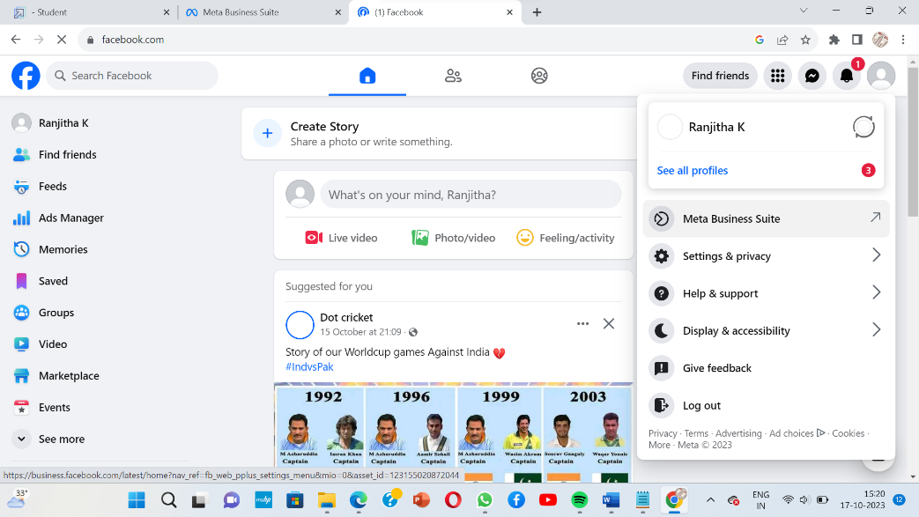

**4. ADS**

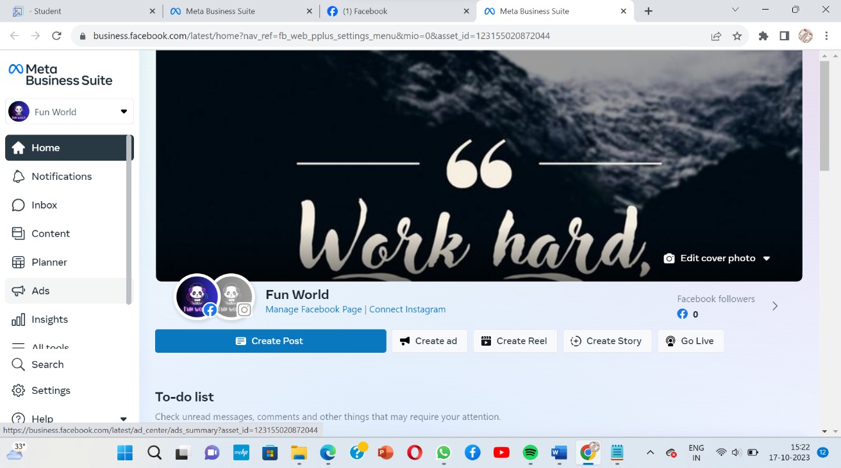

**5. CREATE AD**

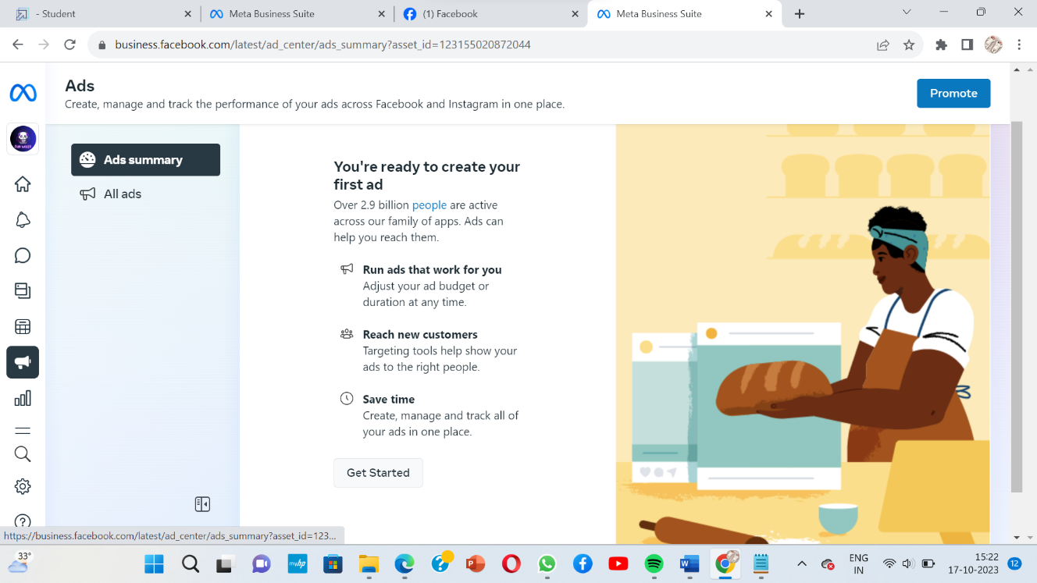

**6. CHOOSE GOAL**

**6.1 MORE LEADS**

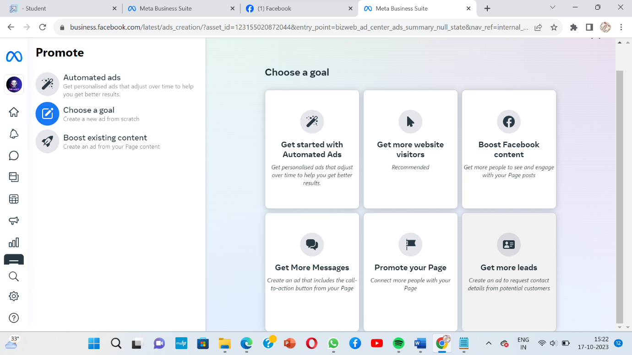

**7. COLLECT CONTACT IN FACEBOOK**

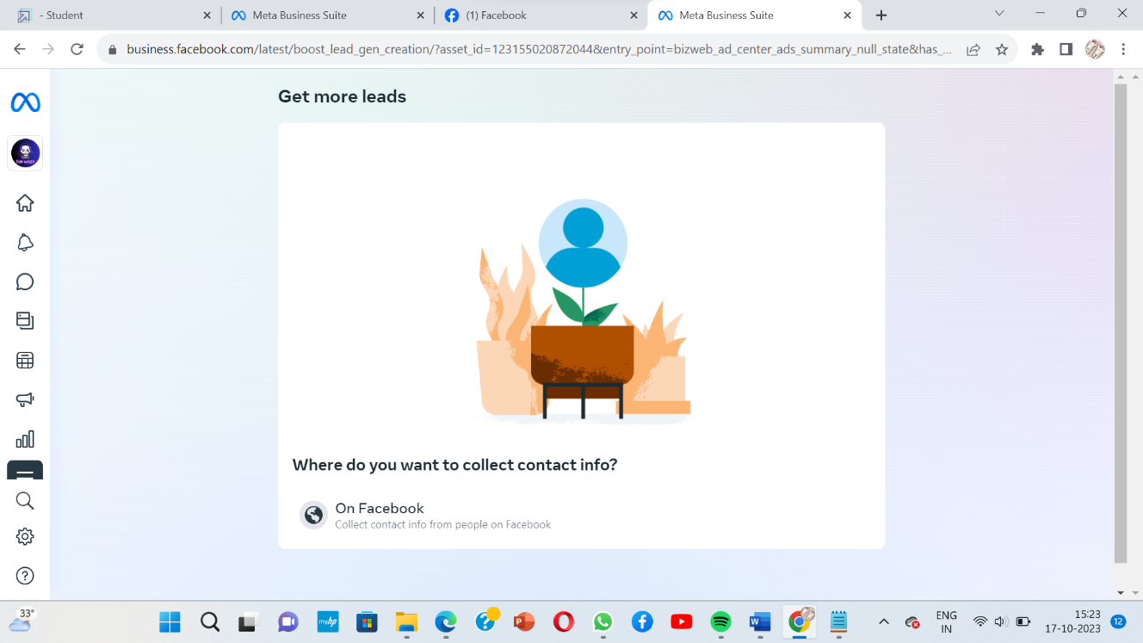

**8.NEW FORM**

**8.1 ADD DETAILS**

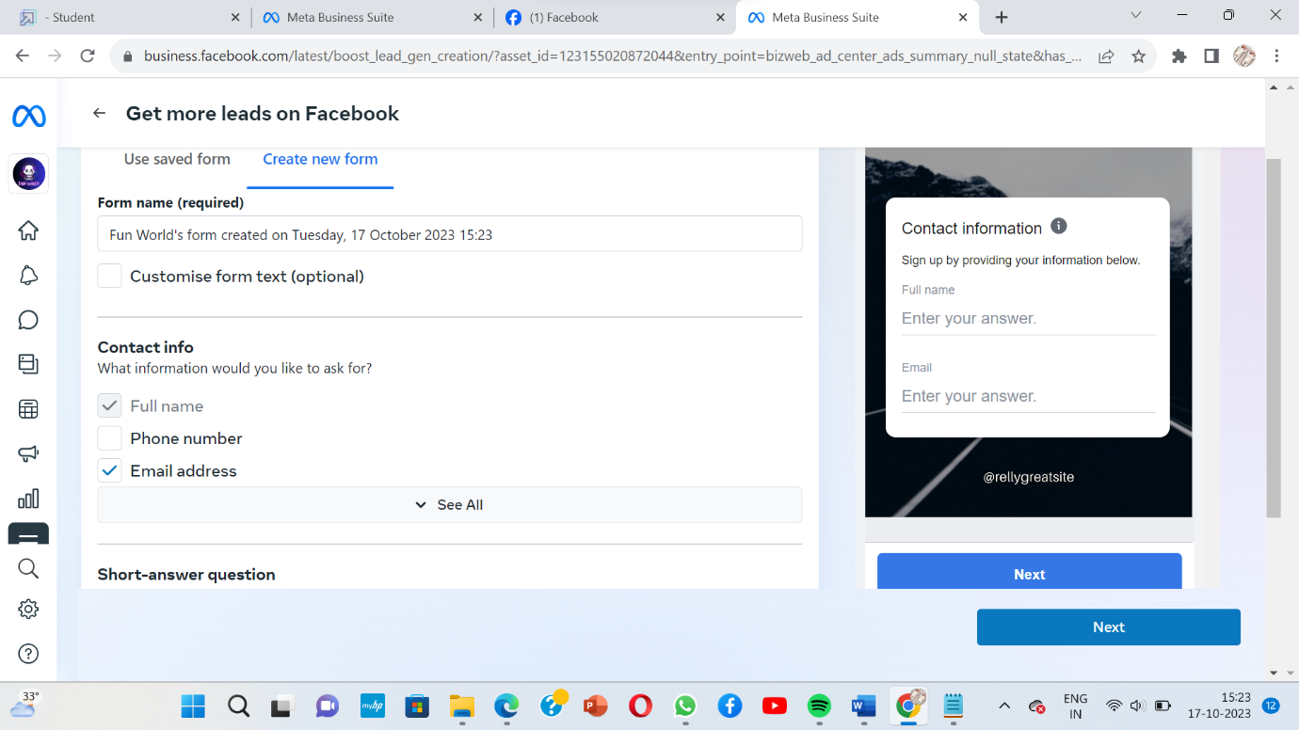

**9. ADD DESCRIPTION**

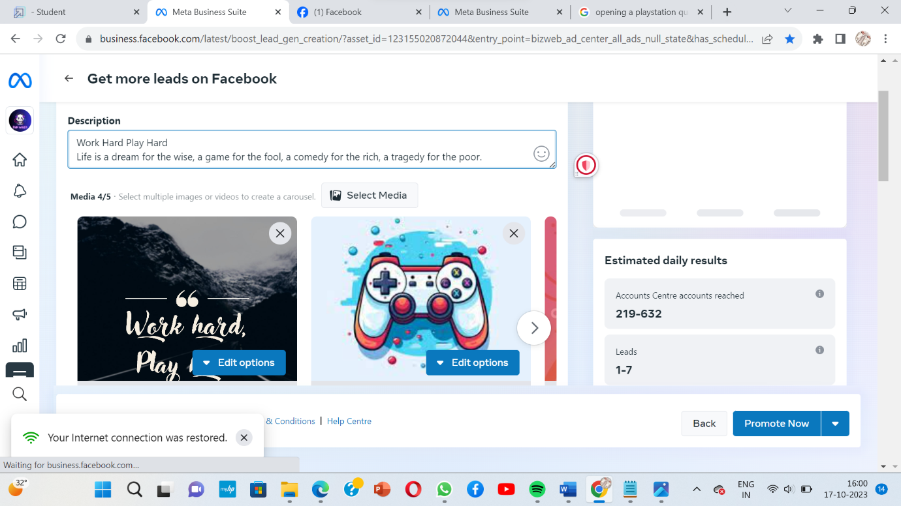

**10. ADD MEDIA**

**10.1 SELCT MEDIA**

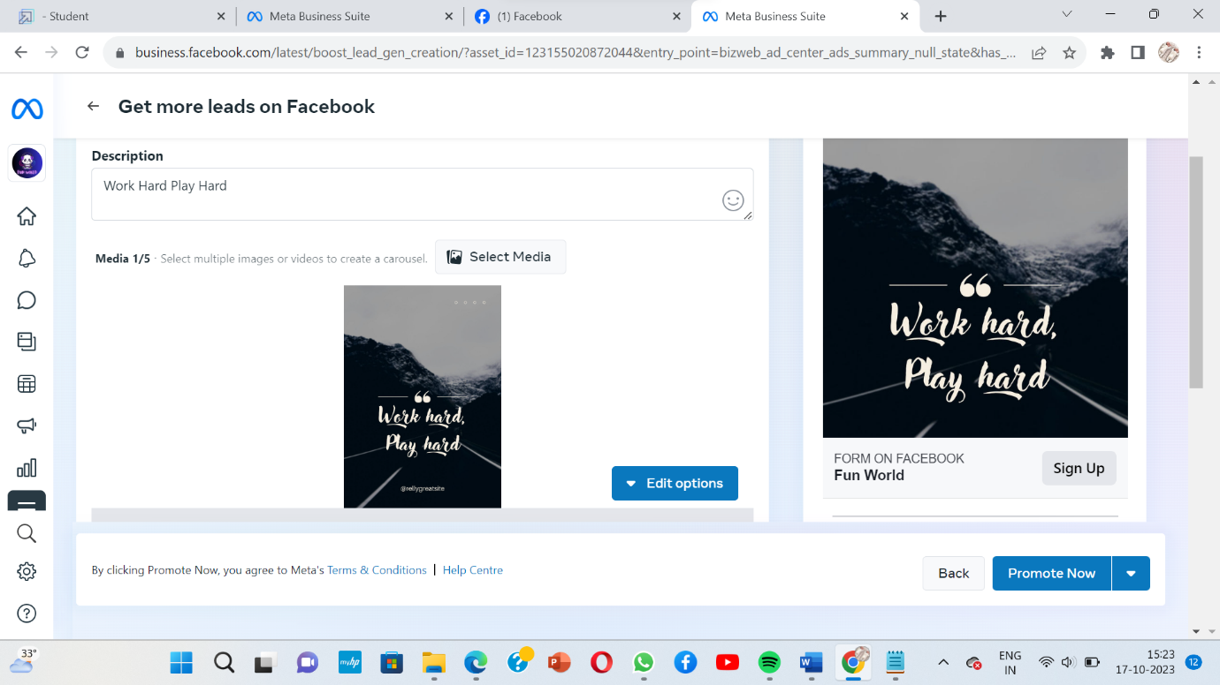

**10.2 UPLOAD IMAGES FOR YOUR AD**

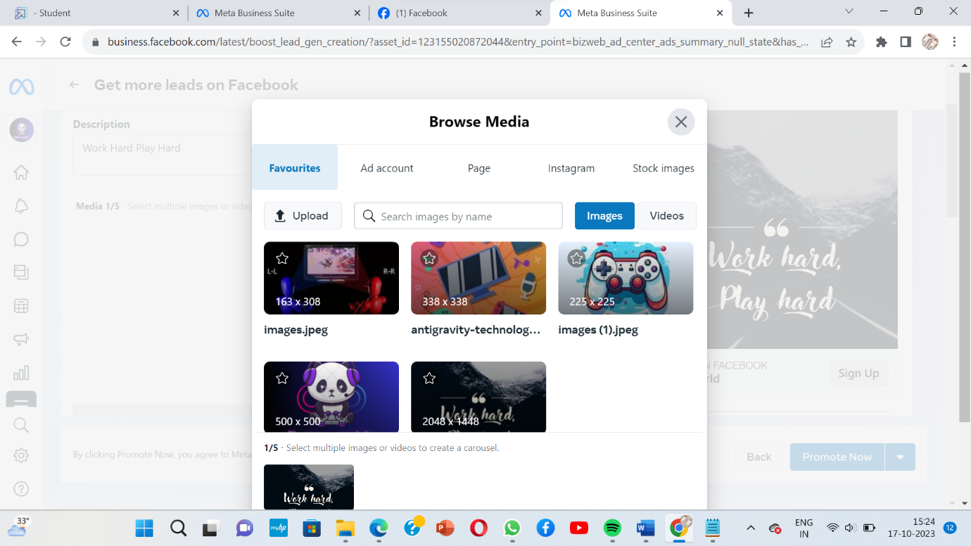

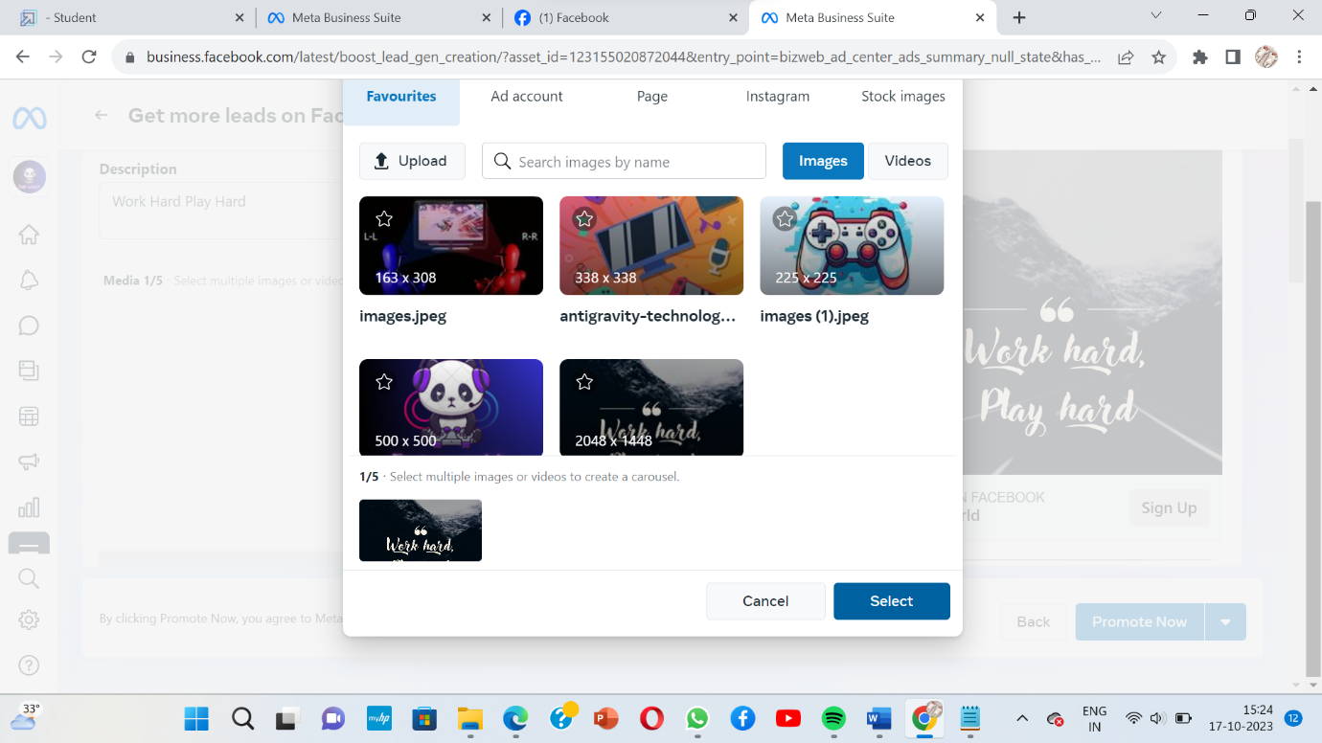

**11. HEADLINE**

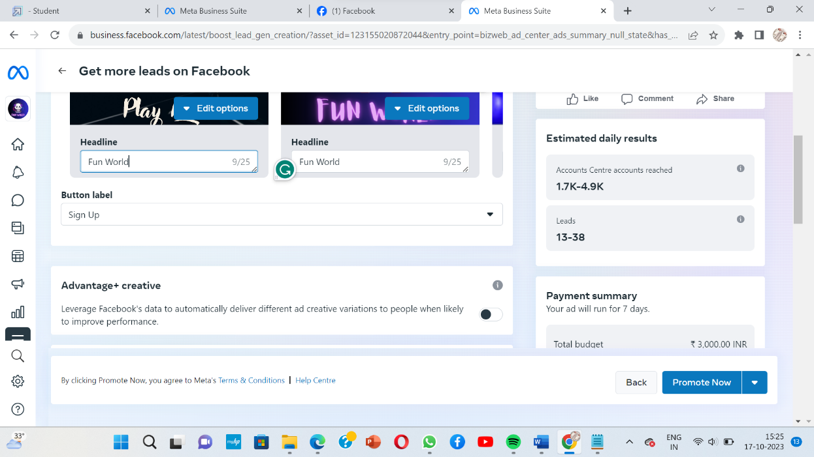

**11.1 ESTIMATED RESULTS**

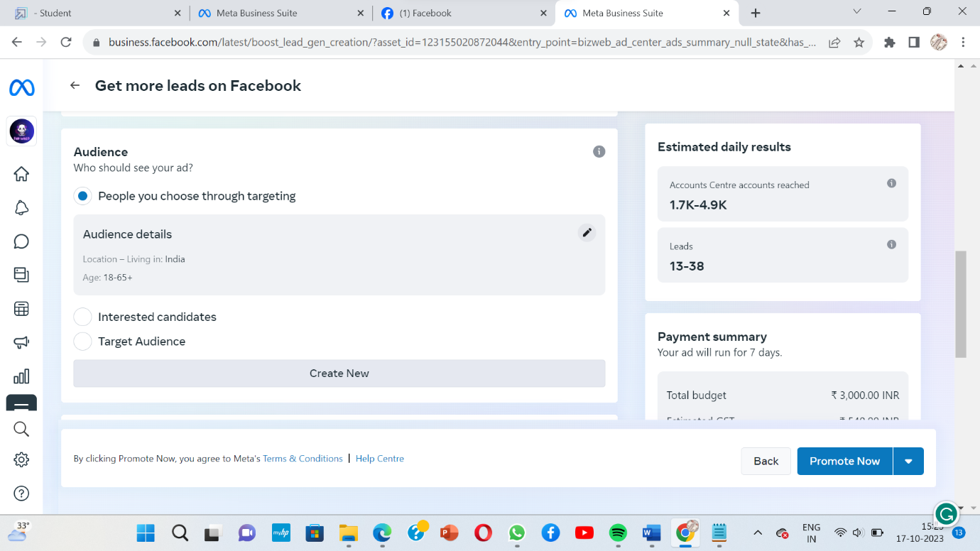

**12. CREATE AUDIENCE**

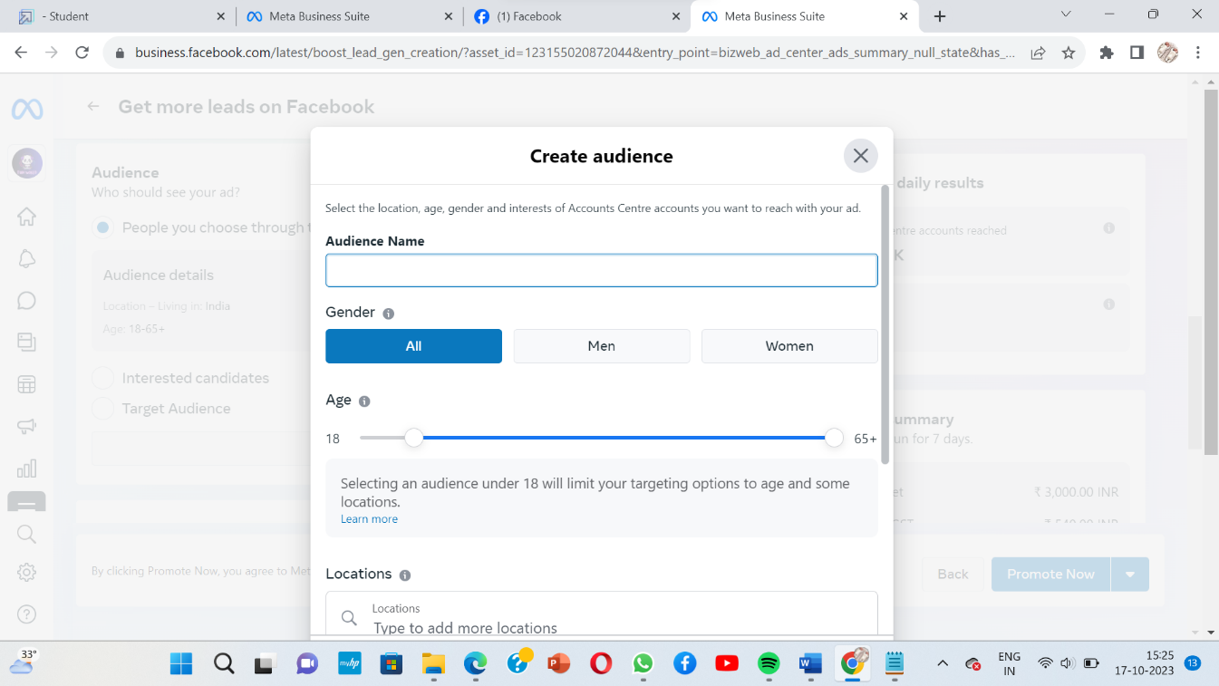

**13. ADD LOCATION**

**13.1 ADD LOCAGTION OF YOUR AUDIENCE**

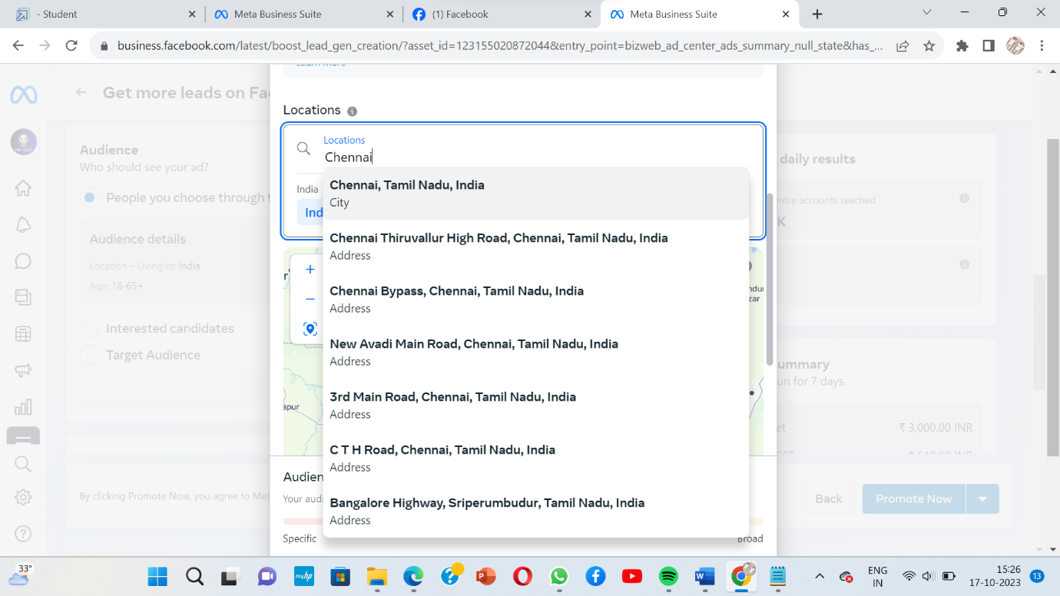

**13.2 DETAILED TARGETING**

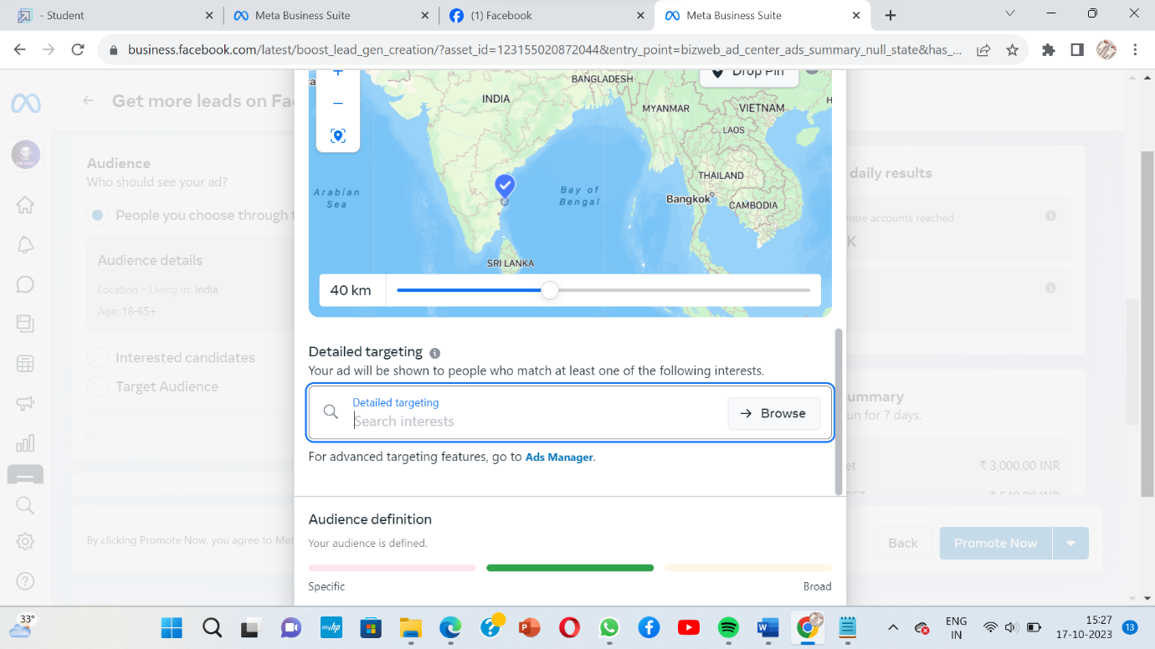

**14. DEMOGRAPHICS,INTEREST,BEHAVIOURS**

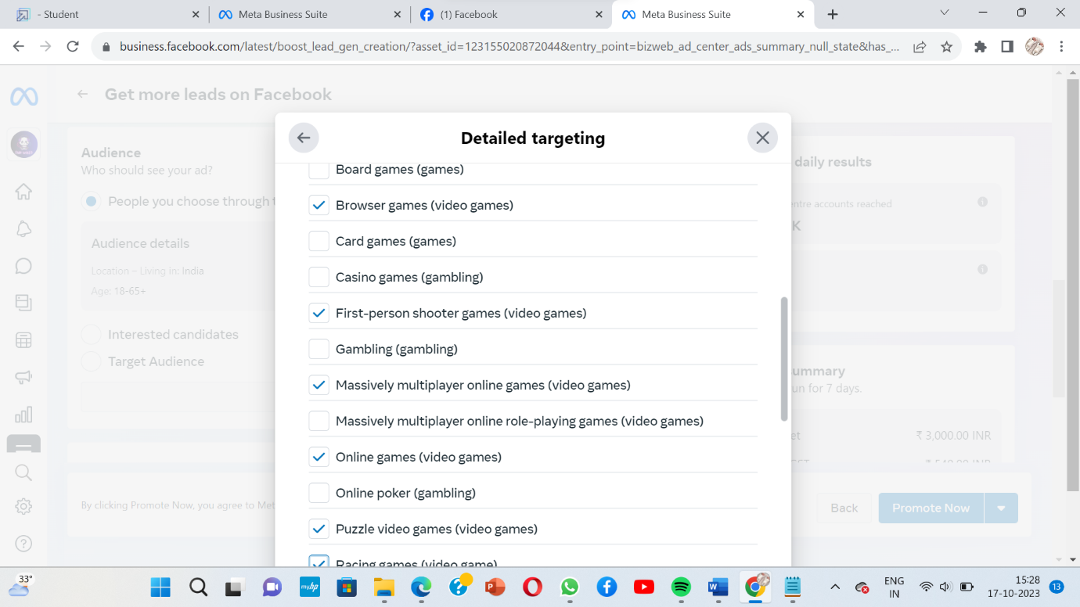

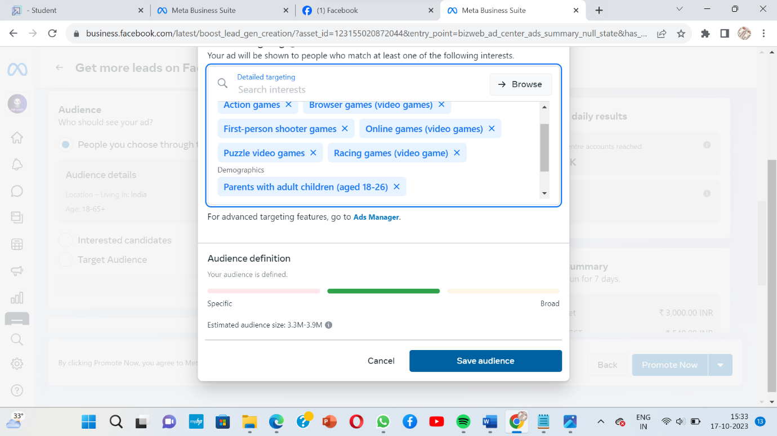

**15. AD DURATION**

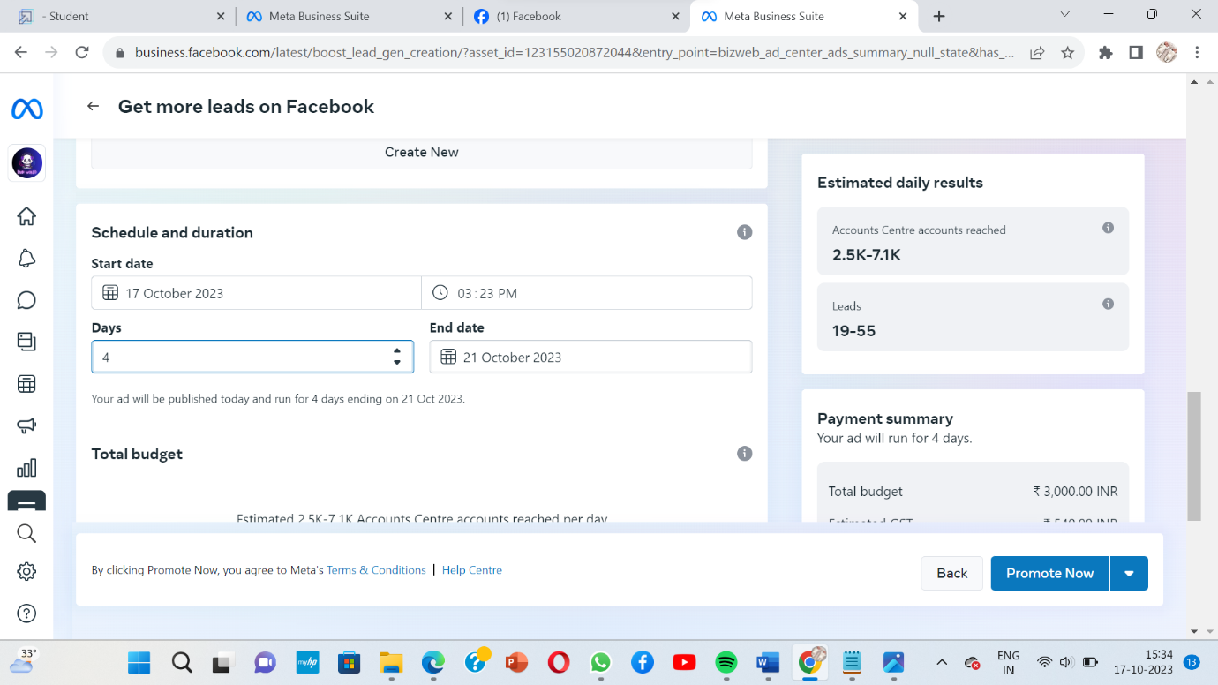

**16. ADD BUDGET**

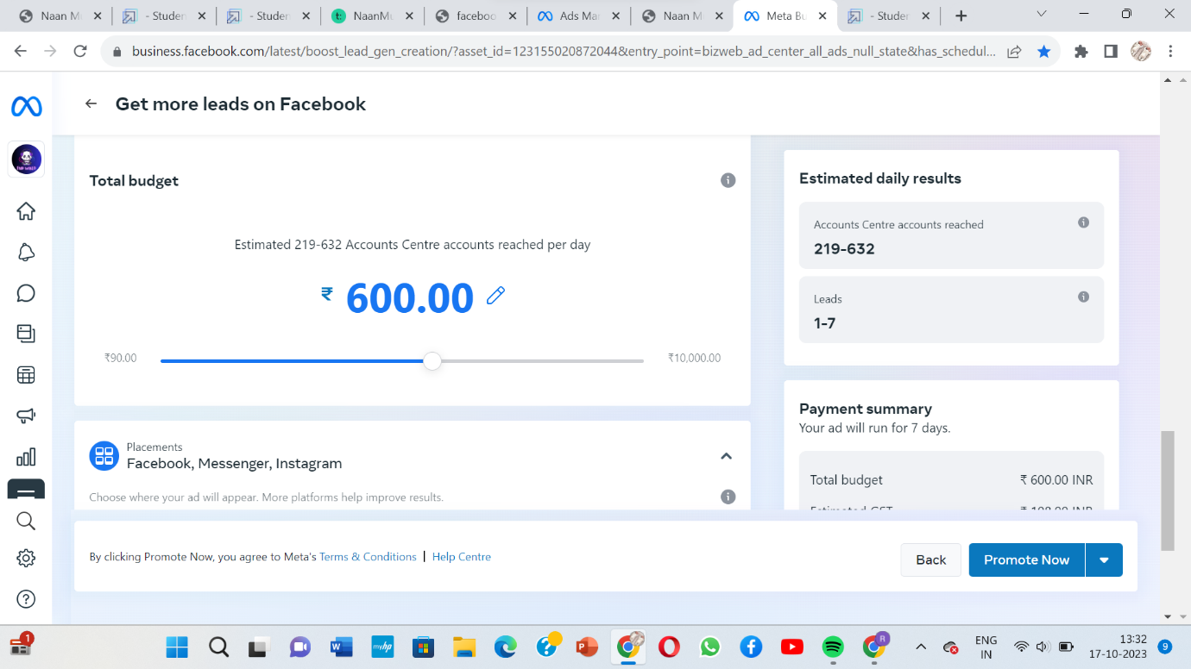

**17. PLACEMENTS**

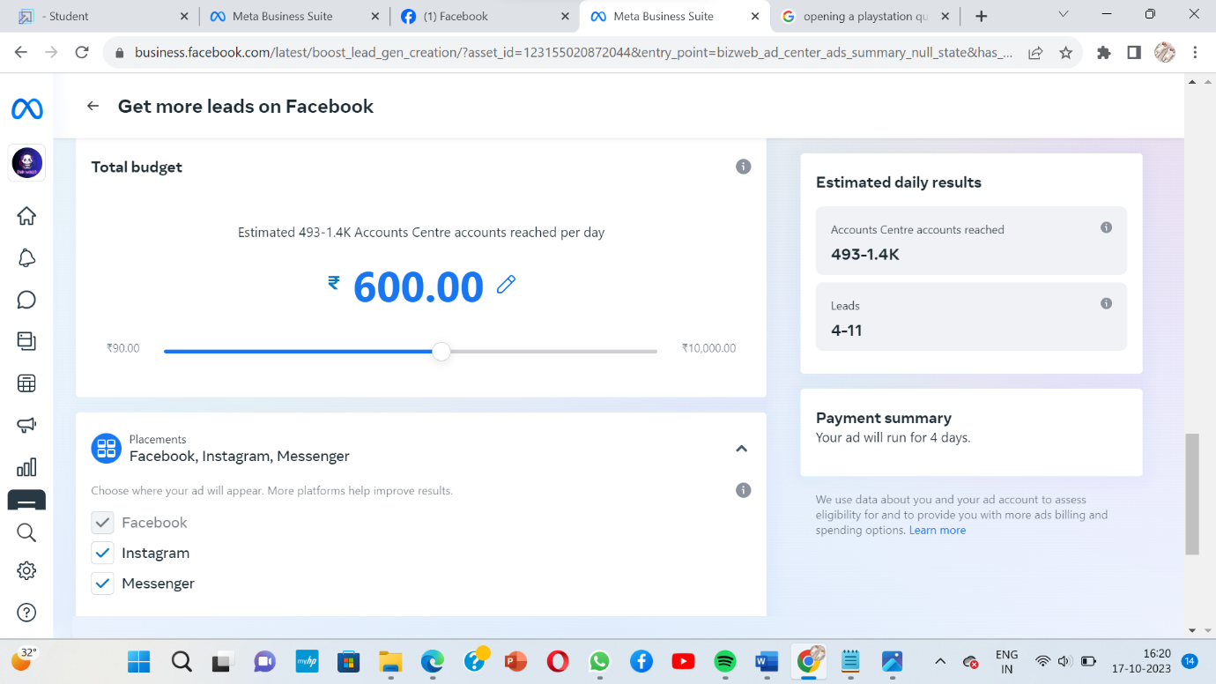

**18. PREVIEWS**

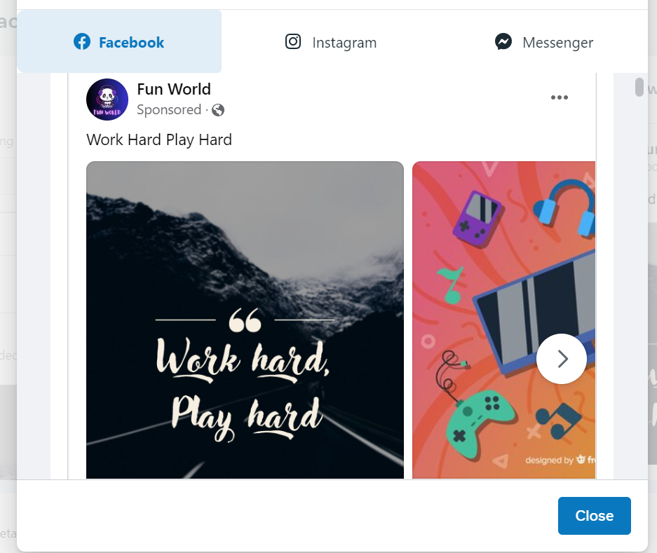

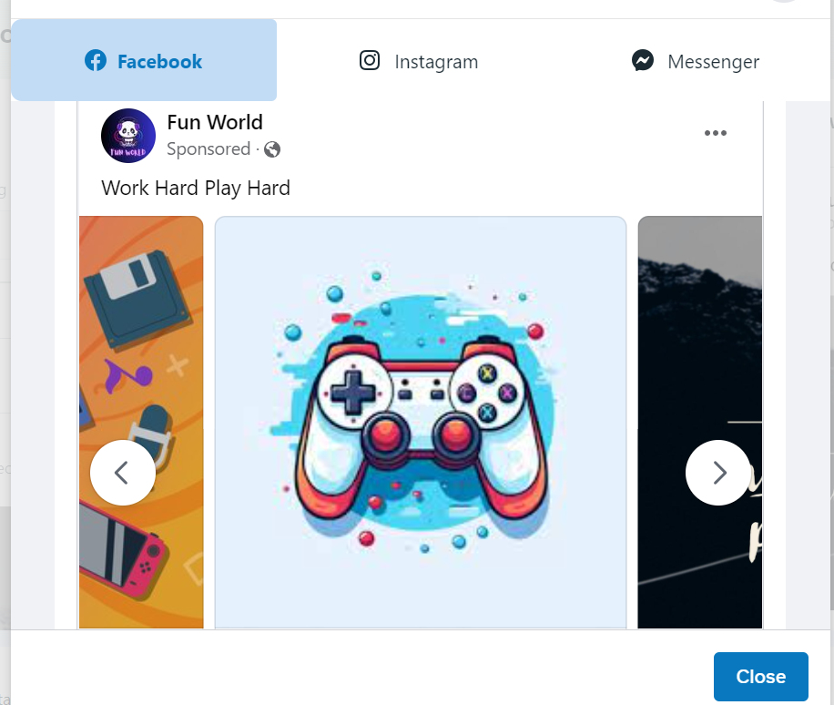

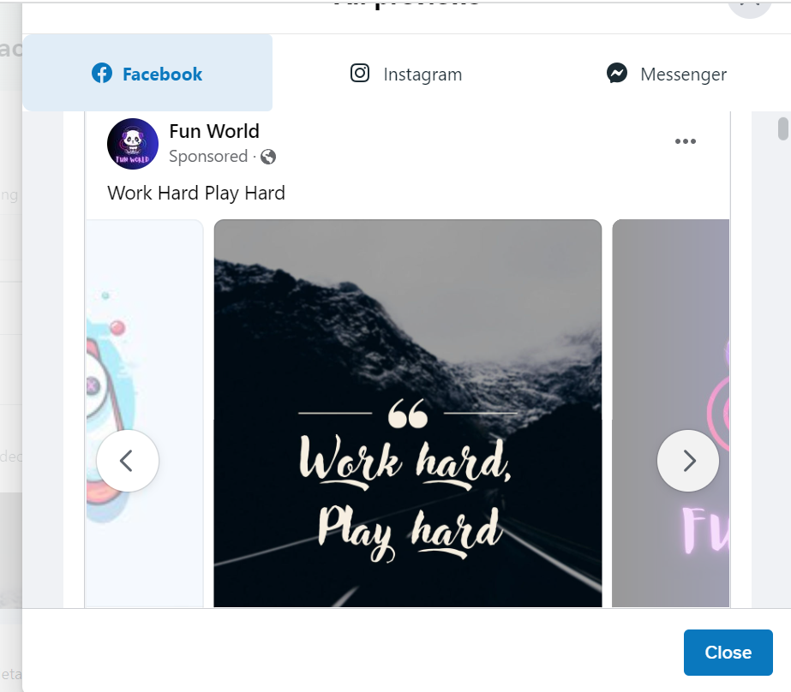

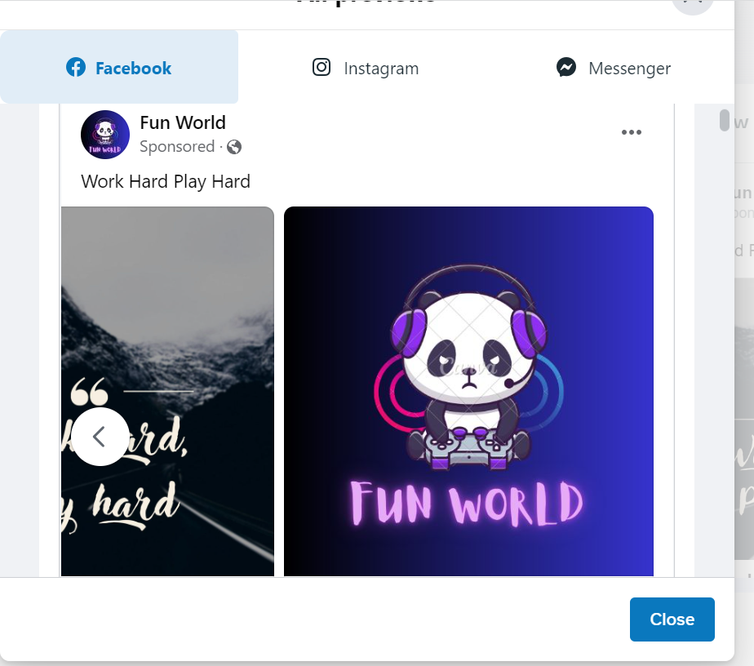

**19. RESULT**

**19.1 BUSINESS EMAIL**

[funworldplaystation123@gmail.com](mailto:funworldplaystation123@gmail.com)

**19.2 GITHUB LINK**

<https://github.com/vickram-D/digital-marking/tree/main>

**20.CONCLUSION**

A conclusion in a social media ad campaign is the final message or content that you use to leave a lasting impression on your audience. It often includes a recap of the key benefits, a strong call to action, and an invitation for the audience to take the next step, whether it's making a purchase, signing up, or engaging with your brand. The conclusion serves to reinforce the main points you've made in your campaign and encourage the audience to take action based on the information you've provided.